Regional Distribution of Electricity Production Sources

Oil Production

The highest oil production is observed in the Middle East & North Africa region (10,710.57 units).

North America has the lowest oil production (61.93 units).

The total oil production across all regions is 46,791.52 units.

Nuclear Production

Europe & Central Asia has the highest nuclear production (10,689.39 units), contributing a significant portion to the global nuclear production.

Middle East & North Africa has the lowest nuclear production (4.23 units).

The total nuclear production across all regions is 17,291.9 units.

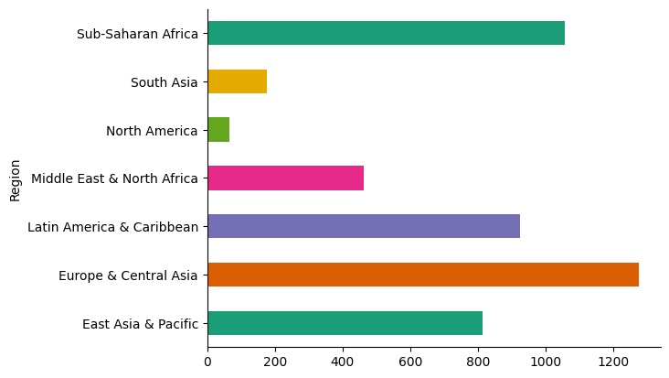

Renewable Production

The highest renewable production is from the Europe and Central Asia, which seems to be an outlier or potentially aggregated data from unspecified regions.

Sub-Saharan Africa has the lowest renewable production (52,225,000,000 units).

Insights

The data indicates a strong reliance on oil and renewable energy in many regions, with Europe & Central Asia and North America showing significant nuclear production.

Renewable energy production has a wide range of values, indicating varying levels of investment and infrastructure across regions.

Middle East & North Africa shows a very low nuclear production compared to its oil production, aligning with the region's known energy profile.

2.Electricity access trends by Year and Income Group

High Income

High Income

.The high-income category has the highest access to electricity (167,481.67 units).

This indicates a well-developed infrastructure and widespread availability of electricity in high-income regions.

Low Income

The low-income category has the lowest access to electricity (15,014.39 units).

This suggests significant challenges in electricity access in low-income regions, highlighting the need for infrastructure development and investment.

Lower Middle Income

The lower middle-income category has a moderate access to electricity (76,636.34 units).

While better than low-income regions, there is still substantial room for improvement.

Upper Middle Income

The upper middle-income category has relatively high access to electricity (102,275.7 units).

This shows that upper middle-income regions have better infrastructure compared to lower middle-income and low-income regions, but still lag behind high-income regions.

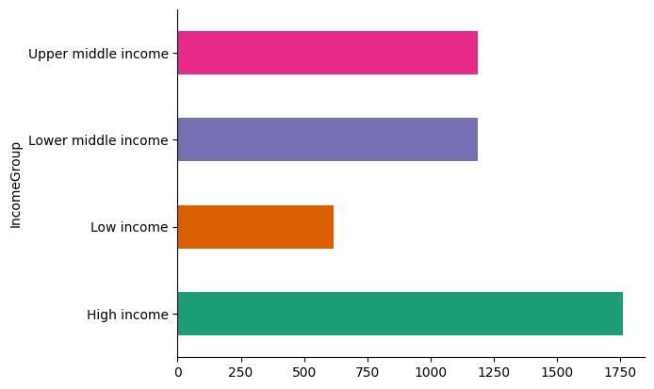

Insights

There is a clear disparity in access to electricity across different income levels, with high-income regions having the best access and low-income regions having the least.

Lower middle-income and upper middle-income regions show a progression in access to electricity, reflecting the economic development stages.

The significant value in the (blank) category needs to be investigated to ensure data accuracy and proper categorization.